Boston University
ENG EK 304
Energy and Thermodynamics

Laboratory Exercise II

BRAYTON CYCLE EXPERIMENT -JET ENGINE

(Based on an instruction set provided by Turbine Technologies Limited, 2002
Modified by L. Colby, K. Pelletier, M. Isaacson, and D. Wroblewski, 2002
Modified by D. Wroblewski, 2003
Engine installed by J. Estano and D. Campbell, 2002)

Objectives:

- To understand the basic operation of a Brayton cycle by observation of the performance of its components in an operating jet engine.

- To apply the basic thermodynamic equations to Brayton cycle component analysis.

Pre-lab Questions (To be done by students prior to laboratory period. Read entire lab handout and accompanying articles before answering):

- How did the introduction of jets on commercial aircraft make it easier for airlines to maintain regular schedules and thus led to the popularization of commercial flying?

- Why is the addition of a couple of percentage points to the efficiency of the gas turbine cycle so important to the electric power industry?

- Given an air compressor operating at steady state with inlet pressure of 105 kPa, inlet temperature of 296 K, outlet pressure of 312 kPa, and outlet temperature of 408 K, determine its isentropic efficiency on a Cold Air Standard basis.

- Given a gas turbine operating at steady state with inlet pressure of 313 kPa, inlet temperature of 1050 K, outlet pressure of 120 kPa, and temperature of 950 K, determine its isentropic efficiency on a Warm Air Standard basis.

Figure 1. Basic Brayton Cycle

Background:
Combustor
Turbine
Compressor
1
2
3
4
W_{IN}
.
W_{OUT}
.
Q_{IN}
.
Atmospheric Air
Hot Exhaust Gases

The Brayton cycle depicts the air-standard model of a gas turbine power cycle. A simple gas turbine is comprised of three main components: a compressor, a combustor, and a turbine. According to the principle of the Brayton cycle, air is compressed in the compressor. The air is then mixed with fuel, and burned under constant pressure conditions in the combustor. The resulting hot gas is allowed to expand through a turbine to perform work. Some of the work produced in the turbine is used to run the compressor and the rest is available to run auxiliary equipment and produce power. The gas turbine is used in a wide range of applications. Common uses include stationary power generation plants (electric utilities) and mobile power generation engines (ships and aircraft). In power plant applications, the power output of the turbine is used to provide shaft power to drive a generator, a helicopter rotor, etc.

In jet engine applications, the aircraft is propelled forward by the reaction thrust of the exiting gas stream. The turbine provides just enough power to drive the compressor and produce the auxiliary power. The gas stream acquires more energy in the cycle than is needed to drive the compressor. The remaining available energy in the working fluid (the air passing through the engine) is used to propel the aircraft forward by being converted from high potential energy (enthalpy) into high kinetic energy (jet velocity) in the nozzle at the exhaust end of the engine.

A schematic of the basic open cycle Brayton (simple gas turbine) cycle is given in Figure 1. Low-pressure air is drawn into a compressor (state 1) where it is compressed to a higher pressure (state 2). Fuel is added to the compressed air and the mixture is burnt in a combustion chamber. The resulting hot gases enter the turbine (state 3) and expand to state 4. In a jet engine, the nozzle would come after state 4. The basic Brayton cycle consists of four basic processes:

12: Isentropic Compression
23: Reversible Constant Pressure Heat Addition
34: Isentropic Expansion
41: Reversible Constant Pressure Heat Rejection (Exhaust and Intake in the open cycle)

A Brayton cycle used for jet propulsion is shown schematically in Figure 2. In addition to the processes described above for a simple Brayton cycle, the jet propulsion cycle includes a diffuser at the inlet of the compressor to slow down incoming air, and a nozzle at the exit of the turbine to produce a high velocity exhaust jet for propulsive thrust. When jet engines are tested at static conditions (i.e., no forward velocity) then the inlet diffuser is normally replaced with a bell shaped inlet to assure smooth flow into the compressor.

Figure 2. Brayton Cycle for Jet Propulsion
Combustor
Turbine
Compressor
Nozzle
1
2
3
4
W_{IN}
.
W_{T}
.
Q_{IN}
.
5
V_{e}
Basic Brayton Cycle
Diffuser

Cycle Analysis:

The First Law of Thermodynamics for open systems determines the overall energy transfer in each cycle component considered separately. To analyze the cycle, we need to evaluate all the states as completely as possible. Air standard models are very useful for this purpose and provide acceptable quantitative results for gas turbine cycles. In these models the following assumptions are made.

- The working fluid is air and treated as an ideal gas throughout the cycle;
- The combustion process is modeled as a constant-pressure heat addition;

In cold air standard (CAS) models, the specific heat of air is assumed constant (perfect gas model). CAS analyses include the solution of closed form equations involving the polytropic relations. The effect of temperature on the specific heat can be included in the analysis at a modest increase in effort. This is called the warm air standard (WAS) model. WAS analyses include the use of the air tables. For this laboratory exercise, you will be required to do the analysis of your data using both CAS and WAS analyses.

To perform thermodynamic analyses on the three components of the engine shown in Figure 1, we consider a separate control volume containing each component of the cycle and utilize the following major (and good) assumptions: the kinetic energy and gravimetric potential energy do not change significantly through the components.

Compressor:

Consider the following control volume for the compressor.

Figure 3. Compressor Control Volume Model
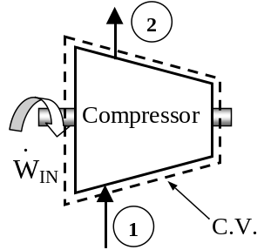
Note that ideally there is no heat transfer from the control volume (C.V.) to the surroundings. Under steady-state conditions, and neglecting the kinetic and gravimetric potential energy effects, the first law for this control volume is then written as
Considering that we have one flow into the control volume and one flow out of the control volume, we may write a more specific form of the first law as
Or, rearranging by grouping the terms associated with each stream,

This is the general form of the First Law for a compressor. However, if the fluid stream is assumed to ideal gases with constant specific heats (CAS) we may represent the enthalpies in terns of temperature (a much more measurable quantity) and get, since dh = c_{p}dT,

For greater accuracy in your CAS analysis of each component, the specific heat of each fluid should be evaluated at the linear average between its inlet and outlet temperature, (T_{in}+T_{out})/2

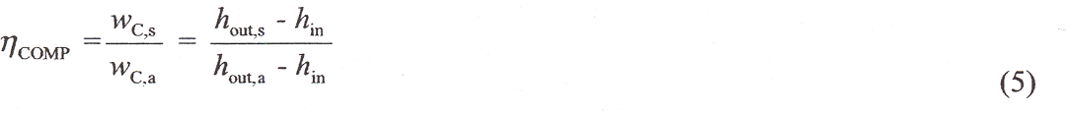
The irreversibility’s present in the real process can be modeled by introducing the compressor efficiency,
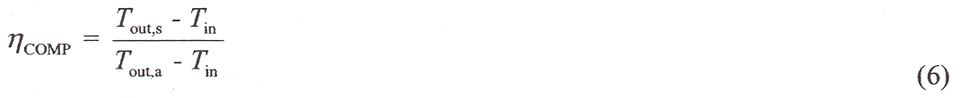
Where the subscript s refers to the ideal (isentropic) process and the subscript a refers to the actual process. For a perfect gas the above equation is reduced to

In equation (6), T_{out,s} can be found from the pressure ratio across the compressor and the isentropic relation

T₂= (T₁) (p₂/p₁) ^{(k-1)/k} (6a)

For a WAS analysis, Equations (3) and (5) are still valid, but the air table must be used to fiund the enthalpy values from the measured temperature and pressures.

Combustor
Consider the following control volume for the combustor,

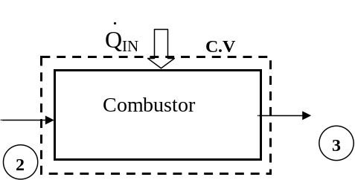Figure 4. Combustor Control Volume Model

Note that ideally there is work transfer from the control volume (C.V.) to the surroundings. Under steady-state conditions, and neglecting the kinetic and gravimetric potential energy effects, the first law for this control volume is then written as
Considering that we have one flow into the control volume and one flow out of the control volume, we may write a more specific form of the first law as
Or, rearranging by grouping the terms associated with each stream,

Assuming ideal gases with constant specific heats, enthalpy differences are readily expressed as temperature differences as
Again, to be more accurate, the specific heat of each fluid should be evaluated at the linear average between its inlet and outlet temperature.

For the WAS analysis, the air table must be used to find the enthalpy values from the measured temperatures.

Turbine
Consider the following control volume for the turbine,

Figure 5. Turbine Control Volume Model

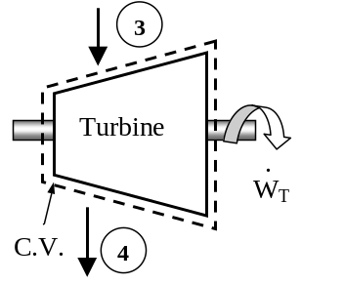
Note that ideally there is no heat transfer from the control volume (C.V.) to the surroundings. Under steady-state conditions, and neglecting the kinetic and gravimetric potential energy effects, the first law for this control volume is then written as
Considering that we have one flow into the control volume and one flow out of the control
volume, we may write a more specific form of the first law as

Or, rearranging by grouping the terms associated with each stream,
Assuming ideal gases with constant specific heats, enthalpy differences are readily expressed as temperature differences as

As before, the specific heat of each fluid should be evaluated at the linear average between its inlet and outlet temperature for more accurate results.

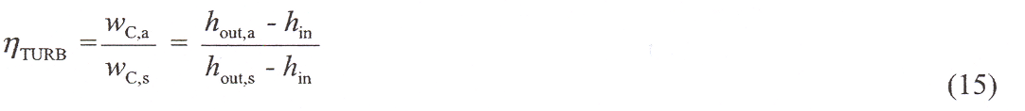
The irreversibility’s present in the real process can be modeled by introducing the turbine isentropic efficiency,

where the subscript s refers to the ideal (isentropic) process and the subscript a refers to the actual process. For a perfect gas the above equation is reduced to
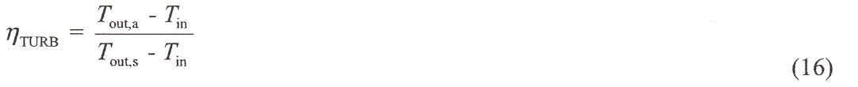
As in the case of the compressor, T_{out,s} can be found from the isentropic relation, and for thw WAS analysis, the air table must be used to find all enthalpy values.

Nozzle
Consider the following control volume for the nozzle,

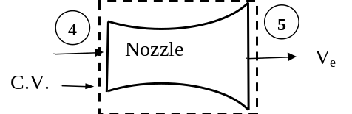Figure 6. Nozzle Control Volume Model

Note that ideally there is no heat transfer from the control volume (C.V.) to the surroundings and there is no work done on or by the nozzle. Under steady-state conditions, and neglecting potential energy effects, and assuming only one input and output stream, the first law for this control volume is then written as

h₄ + ½V₄² = h₅ + ½V₅² (17)

Assuming that the velocity entering the nozzle is negligible compared to the exhaust velocity, this can be written as

V_{e} = [2(h₄-h₅)] ^{1/2} (18)

Assuming ideal gases with constant specific heats,

V_{e} = [2c_{p} (T₄-T₅)] ^{1/2} (19)

Unfortunately, this equation cannot be solved using measured data from the jet engine lab, because the probe used to measure temperature in the exhaust stream measures the “stagnation” temperature, T+½V²/c_{p}. (Note that Equation 17 can be stated in words as follows: the total temperature remains constant through the nozzle.). Similarly, the pressure probe measures “stagnation pressure” p+½ρV². In order to solve equation 19, assume that the expansion in the nozzle is isentropic and that the pressure at the jet exhaust is atmospheric (both are generally good assumptions). The, replace T₅ with T_{5,s} so that the resulting equation for the jet exhaust velocity is

V_{e} = [2c_{p} (T₄-T_{5,s})]^{1/2} (20)

Thermal Efficiency
The thermal efficiency is defined differently for a Brayton jet engine cycle than for a Brayton cycle for power production. For the jet engine case, the thermal efficiency is defined as the ratio of the rate of addition of kinetic energy to the air to the rate of energy input to the combustor. For the case when the engine is at static conditions, the efficiency becomes

η_{t}= ½V_{e}²/q_{b} (21)

Experimental Setup:

The laboratory setup is a self-contained, turnkey and portable propulsion laboratory manufactured by Turbine Technologies Ltd. called TTL Mini-Lab. The Mini-Lab consists of a real jet engine. Therefore, the same safety concerns of running a jet engine are present. Care must be taken to follow all the safety procedures precisely as outlined in the laboratory and stated by your lab instructors. The manufacturer provides the following description of the setup.

"A Turbine Technologies Model SR-30 turbojet engine is the systems primary component. Operational sound and smell are hard to distinguish from any idling, small business jet. The engine's axial turbine wheel and vane guide ring are vacuum investment castings. They are produced from modern, high cobalt and nickel content super alloys (MAR-M-247 and Inconel 718). The combustion chamber consists of an annular, counter flow system, including internal film cooling strips.

Fuel and oil tanks, filters, oil cooler, all necessary plumbing and wiring is located in the lower part of the Mini-Lab structure. A throttle lever is located on the right side of the operator and above the slanted instrument panel. The throttle enables the operator to perform smooth power changes between idle and maximum Nl. Digital engine RPM and E.G. T. gauges, mechanical E.P.R., Oil, Fuel, Air start pressure gauges are also part of the standard panel. Annunciator lights indicate low oil pressure, igniter on, and air-start status. A key operated master switch controls the main electric power bus. Other panel-mounted switches control igniter, air start, and activate fuel flow. The SR-30 engine's fuel system is very similar to large-scale engines-fuel atomization via 6 return flow high-pressure nozzles that allow operation with a wide variety of kerosene based liquid fuels (e.g. diesel, Jet A, JP-4 through 8)."

Engine Components
The engine consists of a single stage radial compressor, a counter flow annular combustor and a single stage axial turbine that directs the combustion products into a converging nozzle for expansion. There is no inlet diffuser on the SR-30 engine; a diffuser is needed to decelerate the flow into the engine during flight. For static operation (i.e., zero speed), a bell-mouth inlet is used instead to assure smooth flow into the compressor. Engine manufacturers typically use similar inlets when static testing engines. The inlets themselves are usually designed and installed by the air-framers (i.e., Boeing, Airbus, etc.), not the engine manufacturers. Details of the engine may be viewed from the 'cutaway' provided in Figs. 7 and 8.

Instrumentation
The sensors are routed to a central access panel and interfaced with data acquisition hardware and software from National Instruments. The sensor locations are shown in Figure 8, and described in Table 1.

Figure 7. Turbine Technologies's SR-30 Engine

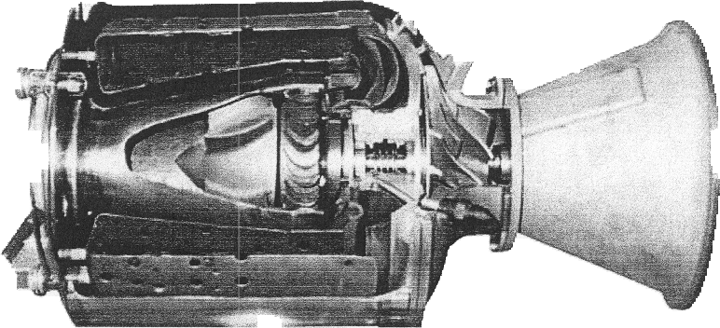

Figure 8. SR-30 Engine Sensor Locations
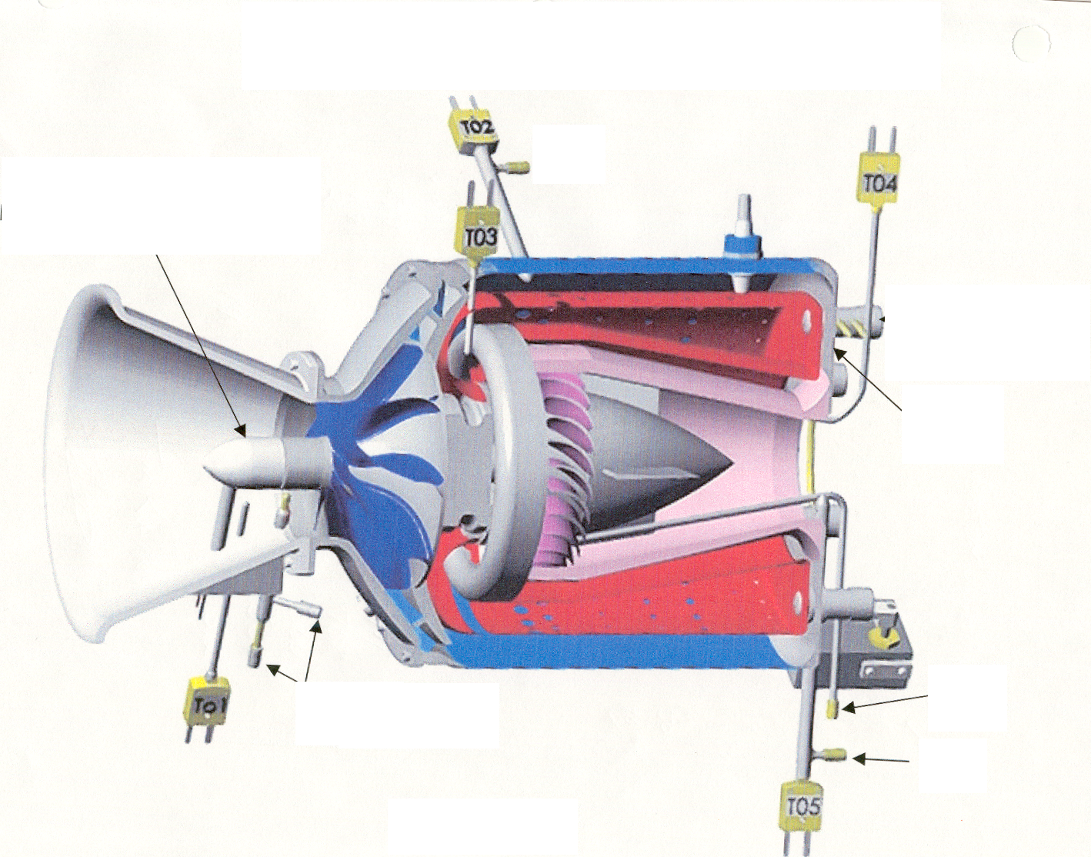
P02
P05
P04
P3
P1 (Pitot/Static)
Engine Tach Generator

Table 1: Sensor Location and Symbols
Sensor | Probe Type | Mini-Lab Symbol
Compressor Inlet Pressure | Pitot/Static | P₁≈P₀₁
Compressor Outlet Pressure | Stagnation | P₀₂
Burner Outlet Pressure | Static | P₃≈P₀₃
Turbine Outlet Pressure | Stagnation | P₀₄
Nozzle Outlet Pressure | Stagnation | P₀₅
Compressor Inlet Temperature | Static | T₁≈T₀₁
Compressor Outlet Temperature | Stagnation | T₀₂
Turbine Inlet Temperature | Stagnation | T₀₃
Turbine Outlet Temperature | Stagnation | T₀₄
Nozzle Outlet Temperature | Stagnation | T₀₅
Engine Shaft Speed | Tach. Generator | RPM
Thrust Force | Strain gauge | T_{f}
Fuel Flow |  | FFS

Experimental Procedure:

SAFETY NOTES
- Make sure you are wearing ear protection and eye protection. If you are not sure how the earplugs are properly used, ask you lab instructor for a demonstration. Never stay in the laboratory without ear protection while the engine is in operation.

- The SR-30 engine operates at high rotational speeds. Although there is a protective pane that separates the engine from the operator, make certain that you do not lean too close to this pane.

- Make sure the low-oil-pressure light goes off immediately after an engine start. If it stays on or comes on at any time during the engine operation cut off the fuel flow immediately by setting the fuel flow switch to “off.”

- If at any time you suspect something is wrong shut off the fuel immediately by setting the fuel flow switch to “off” and notify the lab instructor.

- If the engine is hung (starts but does not speed up to idle speed of about 40,000 rpm) turn the air-start back on for a short while until the engine speeds up to about 30,000 rpm. Then turn off the air-start switch.

- MAKE SURE NEITHER YOU NOR ANY OF YOUR BELONGINGS ARE PLACED IN FRONT OF THE INTAKE TO OR EXHAUST FROM THE ENGINE WHEN THE ENGINE IS RUNNING.

- The exhaust gas duct can be very hot. Stay clear of the duct and NEVER touch the duct during operation..

- The GTF will first review safety information with you before starting the engine.

- Ask your GTF to load the data acquisition program and run the pre-programmed Labview VI for this lab. The screen should display readings from all sensors. Review the readouts to make sure they are working properly.

- Make sure that the air pressure in the compressed-air-start line is at least l00 psia (not exceeding 120 psia). Ask your lab instructor to check the oil level.

- Your lab instructor will turn on the system and start the engine. After the engine is successfully started, you must first allow the engine to achieve the idle speed before making any measurements. Make sure the throttle is at its lowest point. The idle position is nearly vertical, and is close to the operator (away from the engine).

- When the engine has reached idle speed, begin taking data.

- Your instructor or GTF will assign you an engine speed. Slowly open the throttle to that speed. . (Don’t spend a lot of time adjusting the throttle—once the speed is close to your assigned value, then leave the throttle set, even if it drifts a bit). Make sure that you allow the engine time to reach steady state by monitoring the sensor readouts shown on the computer screen. In particular, monitor the compressor outlet temperature, since this is the temperature that tends to reach steady state the slowest. Once you set the throttle, you may have to wait up to a minute or more, before the compressor outlet temperature reaches a steady value. The data acquisition system will be logging data continuously.

- After steady state has been reached at your assigned speed, let it stay there for at least 45 seconds; this should give you 2 or 3 data points at steady state for use in your calculations. Then, slowly bring the throttle up to maximum speed, and allow the system to reach steady state, and then wait for 45 seconds for data collection. When complete, return to your assigned speed and repeat, allowing the system to reach steady state and waiting for 45 seconds for data collection.

- Allow the Labview program to continue taking data. Bring the engine back to idle speed, and then turn off the fuel flow switch. This will shut down the engine. Once the engine has completely stopped, wait for one minute before you stop collecting data.

- The data will be stored in a tab-delimited text file that can be accessed by Excel.

Data Analysis:
Using your collected data to perform the following analysis for each engine RPM:
- Determine the turbine’s specific work and isentropic efficiency and the compressor’s specific work and isentropic efficiency. Use both WAS and CAS analysis
- Calculate the ratio of the turbine work to the compressor work for both the WAS and the CAS analysis.
- Determine the thermal efficiency and the corresponding Carnot efficiency, using the CAS analysis.

For the analysis, use average values of the measured temperatures and pressures, but be sure to average only the values over the time periods that the engine was operating at steady state.

Report:

NOTE: THE GTF WILL PROVIDE YOU WITH DATA FOR A RANGE OF ENGINE RPM FROM THE OTHER GROUPS. USE THESE IN CREATING PLOTS FOR YOUR REPORT.

Include the following items in your report:
- A plot of compressor outlet temperature as a function of time for the entire set of data, to show that the system reached a steady state for each engine speed.
- Your complete Excel spreadsheet highlighting on it the ranges of data used for averages.
- A table showing component efficiency and component work for both compressor and turbine as functions of rpm). Also, present a table showing clearly the input data you used in your analyses. On a full-page graph, plot the results of your analyses for component efficiencies as functions of engine rpm. Use different symbols for the compressor and turbine, and for CAS and WAS, but do not connect the symbols with lines. Properly label your graph. Are the component efficiencies reasonable? Is the turbine work equal to the compressor work? Which analysis CAS or WAS gives more accurate results?
- A T-s diagram for the cycle for the maximum engine RPM case. Also plot the ideal cycle case on the same plot. Give T and s values on the axes corresponding to the principal states you used in your analyses (measured and calculated for isentropic processes).
- Sample calculations for both analyses.

Suggestions for Discussion:

- How does the cycle efficiency compare with the ideal Brayton cycle? With the Carnot cycle?
- How does the component efficiency affect the cycle efficiency?
- How do the component efficiencies you calculated based on your test data compare with those of typical gas turbine engines?

